XVIII Symposium in Pesticide Chemistry

Balancing Water Conservation and Pest Control: Assessing Environmental Risk of Irrigation Methods in Italian Rice Cultivation
Diego Voccia, Lucrezia Lamastra, Arianna Facchi, Olfa Gharsallah, Marco Trevisan


Presenter Diego Voccia
Distas
Università Cattolica del Sacro Cuore
Via E. Parmense 84
Piacenza-Italy

OBJECTIVES

- Use of the recently upgraded Environmental Potential Risk Indicator for Pesticides (EPRIP) [1] to assess the potential movement of pesticides into groundwater, surface water, and canal sediment for two alternative irrigation methods in paddy rice systems.
- Evaluate the single and overall risk associated with the use of applied pesticides, focusing more on herbicides MCPA and Clomazone.

HIGHLIGHTS

- Two water-saving irrigation methods were investigated: dry seeding with delayed flooding (DFL) and wet seeding with alternate wetting and drying (AWD).
- AWD proved economically viable and reduced irrigation needs during peak water demand (June) without significantly affecting rice yield or quality.
- DFL resulted in lower EPRIP scores, indicating a reduced risk of environmental contamination despite the application of an additional active ingridient (Pendimethalin).
- In both irrigation systems groundwater show highest risks.
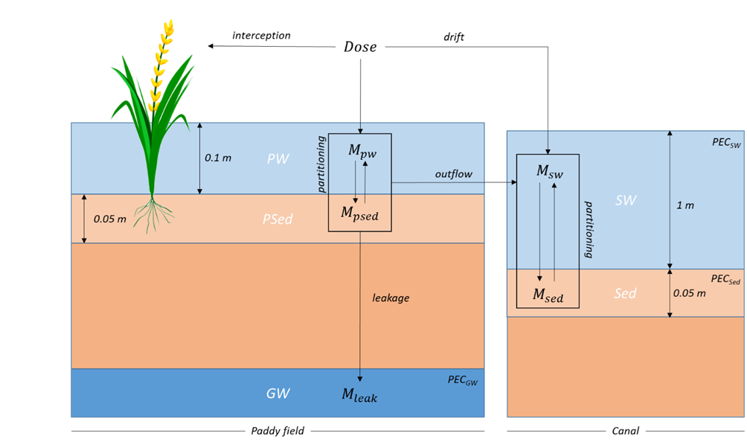
Scenario description for surface water (SW), groundwater (GW) and sediment (Sed) for PEC calculations, considering Paddy Water (PW) and Paddy Sediment (PSed) partitioning, interception, outflow, drift and leakage of the mass (M).

REFERENCES

[1] D. Voccia, L. Lamastra, G. Fragkoulis, A. Facchi, O. Gharsallah, F. Ferrari, A. Tediosi, M. Trevisan, “Improving a herbicide risk assessment model in paddy rice cultivation,” Heliyon. 10, e26908, 2024, doi:https://doi.org/10.1016/j.heliyon.2024.e26908.

