XVI Symposium in Pesticide Chemistry

Studying the effects of trifloxystrobin and its main soil metabolite on soil microbes using advanced culture-independent approaches

Nicoleta Alina Suciu , Andrea Ferrarini, Edoardo Puglisi, Sotirios Vasileiadis, Chrisostomos Oplos, Flavio Fornasier, Sławomir Sułowicz , Luigi Lucini, Dimitrios G. Karpouzas, Marco Trevisan

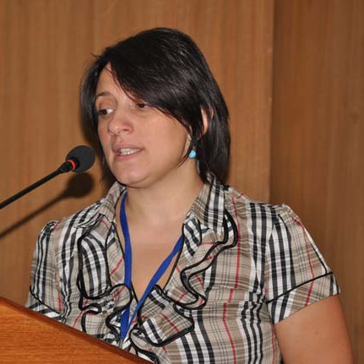
Presenter Nicoleta Alina Suciu
DiSTAS
Università Cattolica del Sacro Cuore
Via E. Parmense 84
Piacenza-Italy
nicoleta.suciu@unicatt.it

Piacenza – Italy
Email

OBJECTIVES
- address associated knowledge gaps concerning the potential toxicity of trifloxystrobin (TFX) and CGA 321113 on the soil microbial community;
- assess soil microbial enzymatic activities after TFX application;
- assess TFX dissipation and CGA 321113 formation/degradation in soil.

HIGHLIGHTS
- Identification of TFX and of its metabolite CGA 321113 was carried out via high resolution mass spectrometry
- Confirmation of TFX and of its metabolite CGA 321113 was carried out by tandem mass spectrometry and molecular structure correlation;
- Dissipation assessment revealed that DT₅₀ of TFX in soil was less than 5 days
- The highest formation rate of the metabolite was in the first 15 days;
- TFX was correlated positively with the potential nitrification activity;
- No effect of TFX on other measured extracellular enzyme activities were observed;
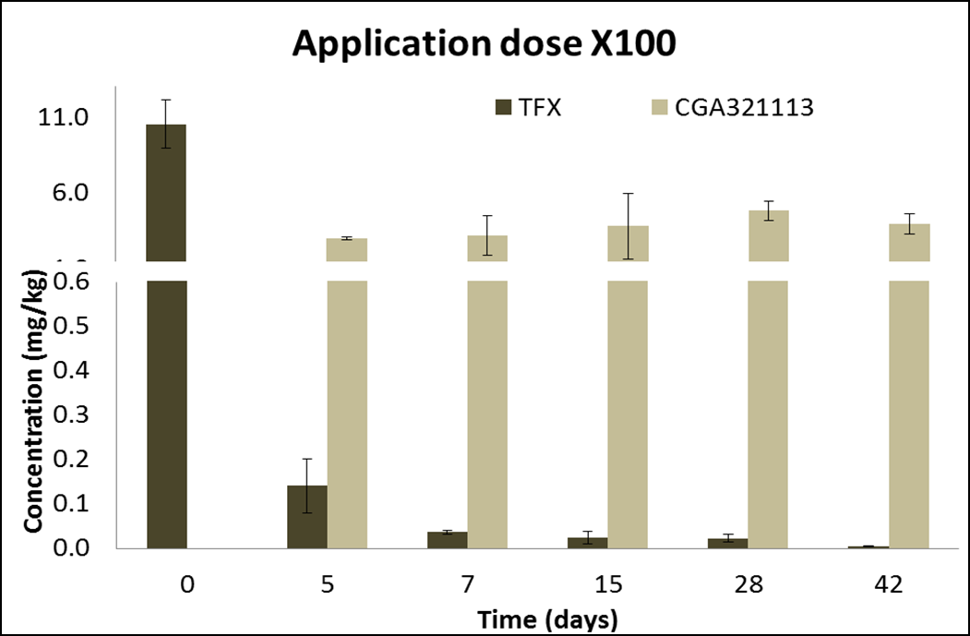
Dissipation of TFX in soil at an application rate equal to 100 times higher than the recommended dose.

